**Personalized Health and Fitness Plan**

**1. Current Physical and Dietary Status**

At 19 years old and weighing 76 kg, I recognize that my current body composition includes excess body fat due to a low level of physical activity. My daily meals typically consist of traditional Indian household food such as chapati, rice, dal, vegetables, and curd. While this provides basic nutrition, my diet lacks focus on high-protein intake necessary for muscle growth and fat loss. Additionally, my daily activity level is minimal, which contributes to decreased metabolism and overall fitness.

Current vs. Ideal Health Metrics

|  |  |  |
| --- | --- | --- |
| Metric | Current | Ideal |
| Weight | 76 kg | 70 kg |
| Activity Level | Minimal | Moderate to Active |
| Water Intake | ~1.5L/day | 2.5–3L/day |
| Protein Intake | Low | Moderate to High |

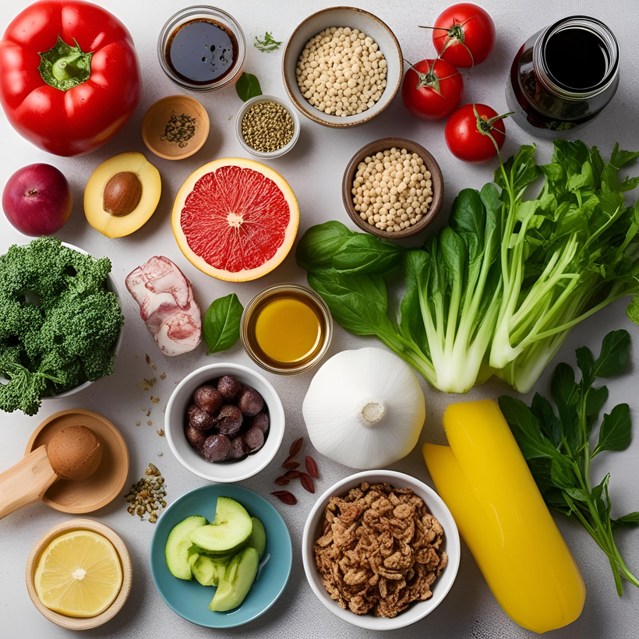

**2. Long-Term Health Goals**

To improve my overall well-being, I have set the following long-term health and fitness goals:

* Reduce body fat percentage in a healthy and sustainable manner.
* Build lean muscle mass through resistance training and a protein-rich diet.
* Improve cardiovascular endurance with regular physical activity.
* Develop consistent and healthy lifestyle habits that can be maintained long term.
* Enhance mental focus, emotional balance, and overall energy levels.

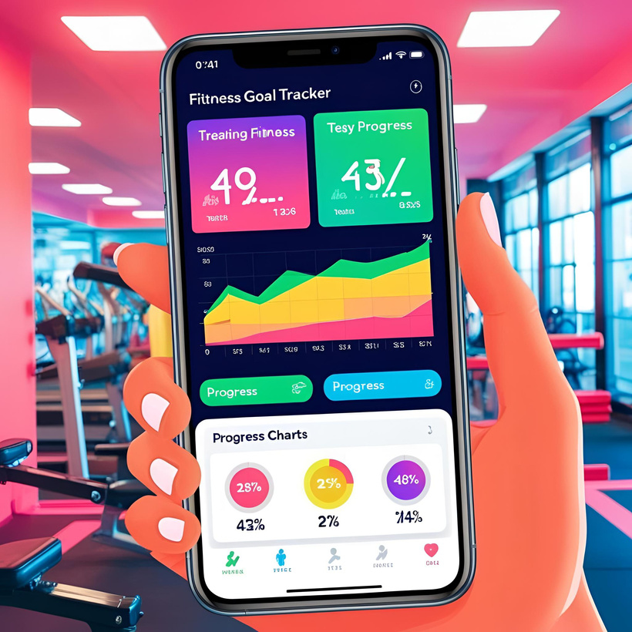

**3. Weekly Fitness Routine**

To achieve my fitness goals, I have created a structured weekly workout plan that includes strength training, cardio, flexibility, and rest days.

|  |  |
| --- | --- |
| Day | Activity Description |
| Monday | Full-body strength training (push-ups, squats, lunges) |
| Tuesday | Cardio workout (jogging, brisk walking, or cycling) |
| Wednesday | Core exercises (planks, crunches) + stretching/yoga |
| Thursday | Light activity (walking, yoga) or active recovery |
| Friday | Strength training (upper/lower body split) |
| Saturday | High-intensity interval training (HIIT) or a sports session |
| Sunday | Rest and muscle recovery |

This plan focuses on building strength, burning fat, and improving overall endurance, while allowing time for recovery and flexibility.

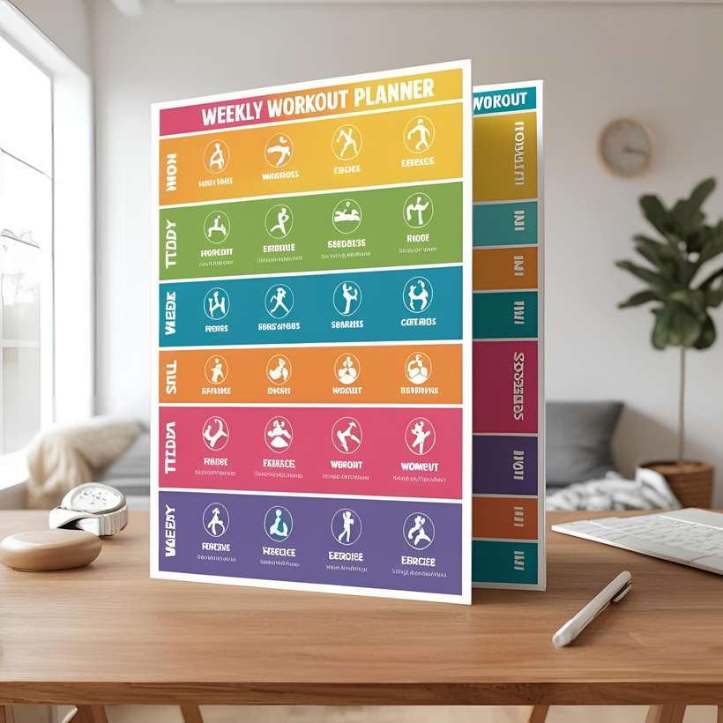

**4. Diet & Mental Wellness**

A balanced diet and mental wellness practices are crucial for long-term health. Below is a sample daily meal plan tailored to support fat loss and muscle gain:

**4.1 Daily Dietary Plan**

|  |  |
| --- | --- |
| Meal | Recommended Items |
| Breakfast | Oats or eggs, a glass of milk, fruits, or paneer |
| Lunch | 2 chapatis, dal, green vegetables, curd |
| Snack | A handful of almonds/walnuts, fruit, or protein shake |
| Dinner | Rice or chapati with dal and lightly sautéed veggies |

This diet ensures I get a mix of protein, complex carbs, fiber, and healthy fats throughout the day.

**4.2 Mental Wellness Routine**

To maintain emotional balance and mental clarity, I will follow these habits:

* Practice 10 minutes of mindfulness or meditation daily
* Sleep 7–8 hours every night
* Journal thoughts or affirmations weekly
* Reduce screen time before bed
* Practice daily gratitude and positive self-talk

Combining good nutrition with mental self-care will help me stay motivated and consistent.



**5. Monitoring and Progress**

To stay aligned with my health goals, I will track my progress every 4 weeks. This includes monitoring physical changes, strength improvements, energy levels, and overall well-being. Adjustments will be made to my diet or fitness plan based on these observations.

**5.1 Weekly Progress Checklist**

* Completed all scheduled workouts
* Met daily water intake goal (2.5–3L)
* Followed the planned diet with healthy meals
* Practiced mindfulness or mental wellness activity
* Slept 7–8 hours each night

Regular self-assessment and small, consistent improvements will help me build lasting habits and achieve my fitness and wellness vision.

Motivational Quote   
 "Discipline is the bridge between goals and accomplishment." – Jim Rohn